**Business Intelligence guide to creating dashboards**

**Creating a New Dashboard**

**a)** Click on the arrow to expose the drop down menu under New  
**b)** Select Dashboard from the Menu drop down. A New Blank Dashboard will be exposed with a blank tile.

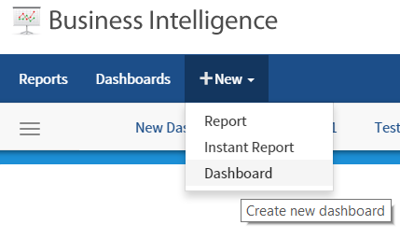

**Adding Report Parts to the Dashboard Tile**

**c)** Click on the + sign to add a Report Part to the new Dashboard

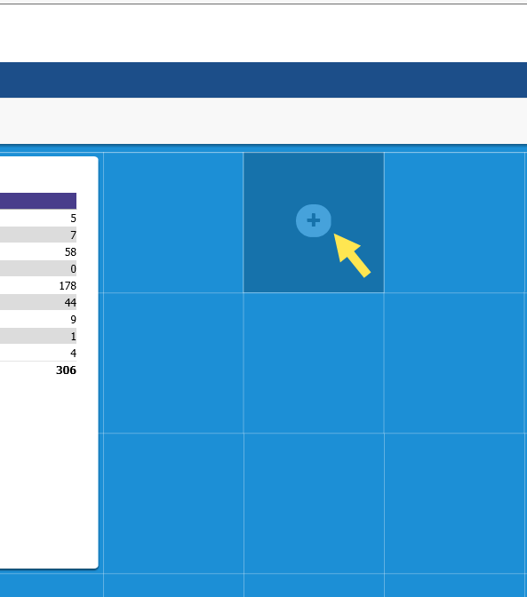

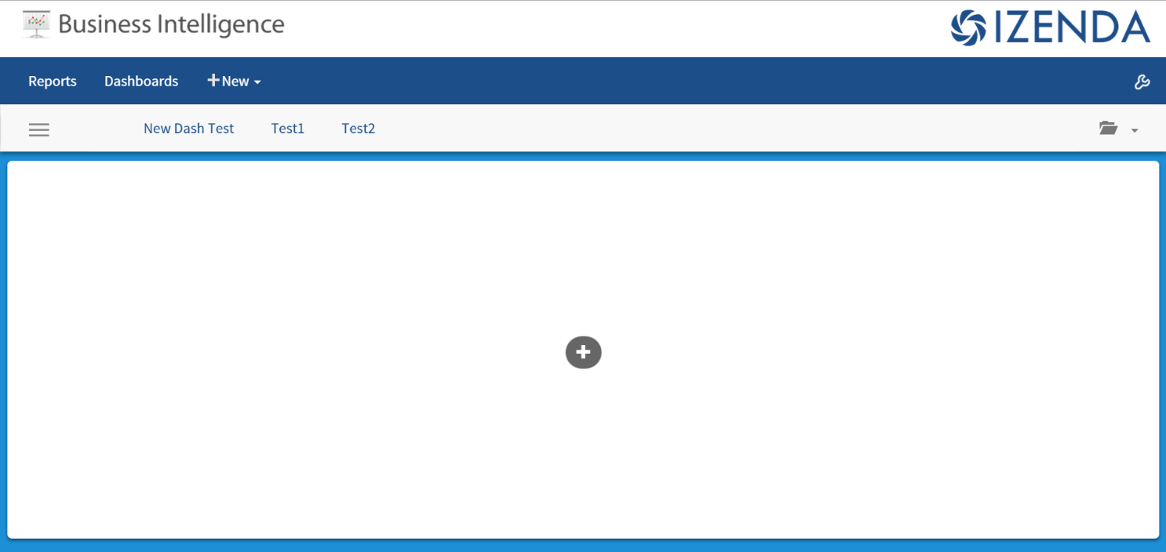

**d)** The user can now select a report to use in the dashboard.

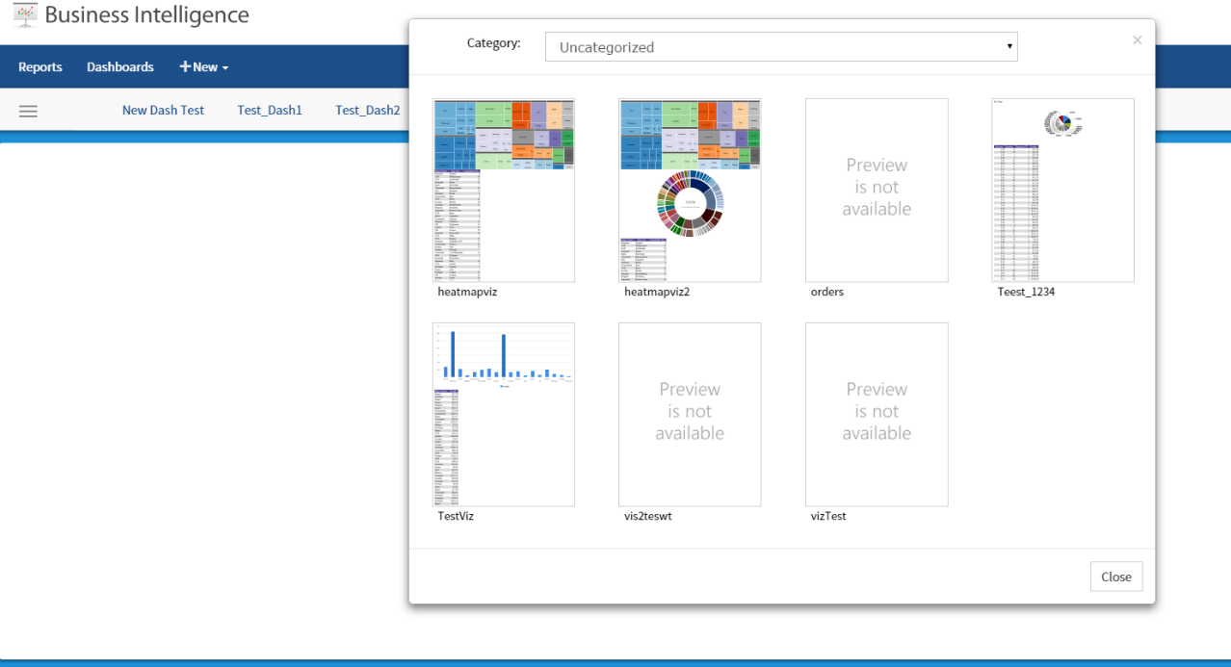

**e)** Once a report is selected, the user is presented with a window displaying all of the report parts as options to add to the new dashboard. These can include charts, maps, gauges, summaries or report details.

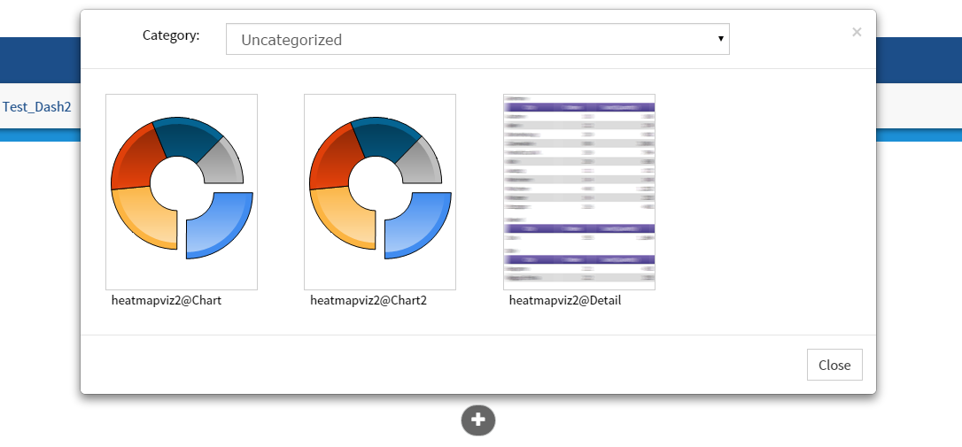

**f)** The report part selected will then be displayed to the user.

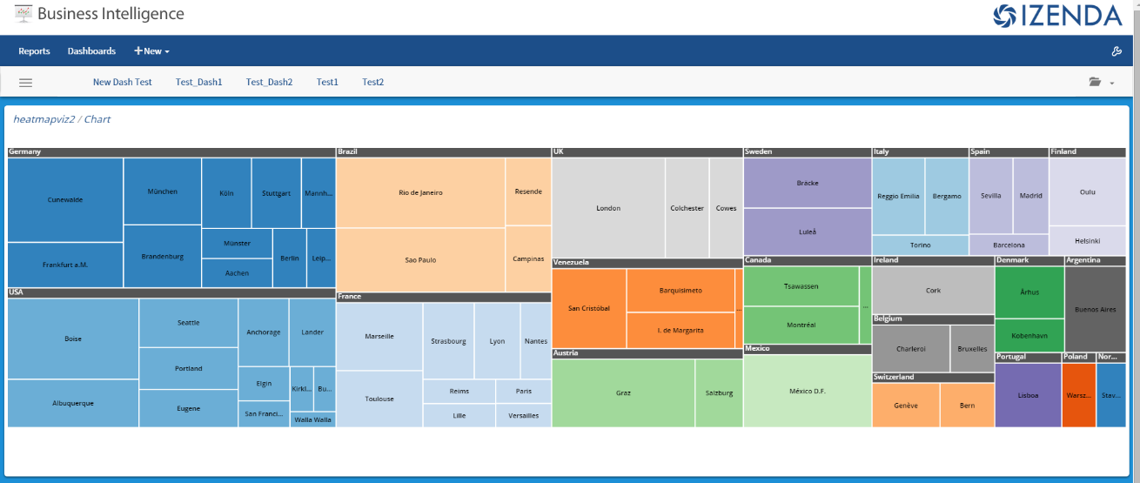

To remove a tile, simply click the “X” in the top right corner of the tile.

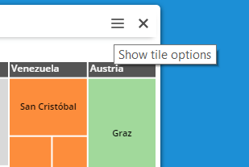

To add additional tiles to the dashboard, the user can click on a blank area of the dashboard background.

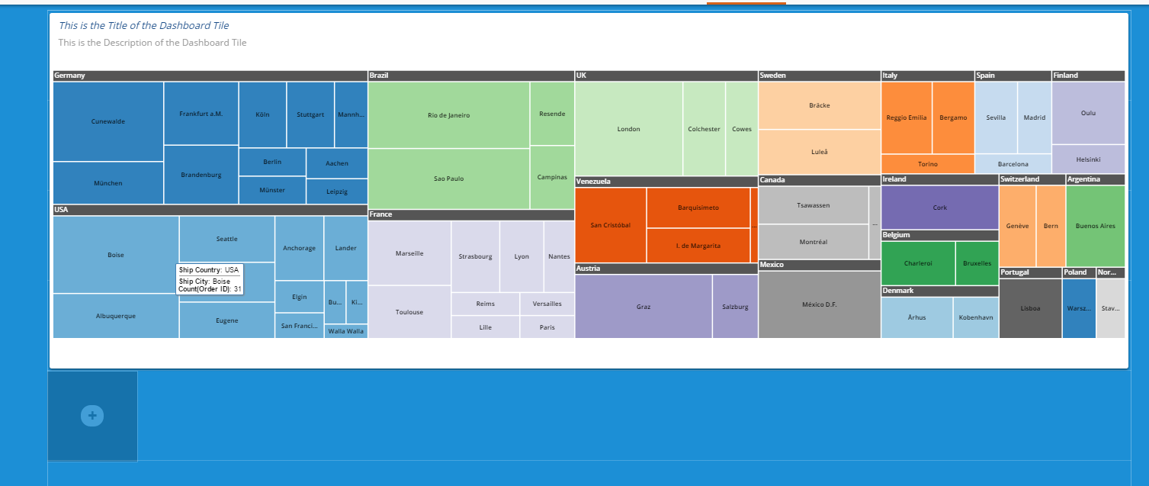

A new blank tile will then be displayed.

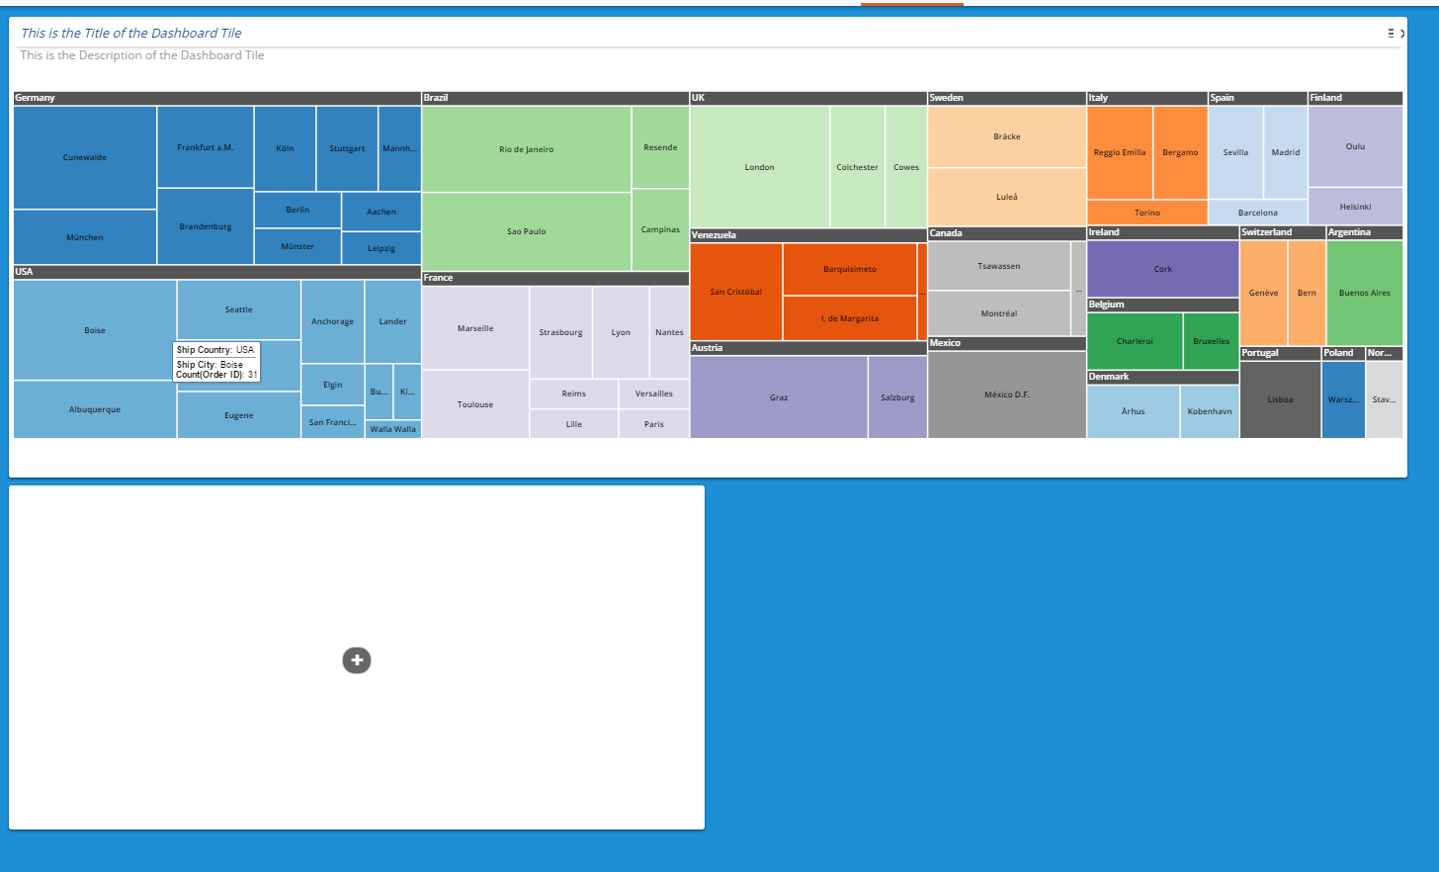

The user can repeat the process to add additional tiles

**Moving & Resizing Dashboard Tiles**

The tiles can be resized by dragging the corners to the desired length or width. Tiles can also be moved around the Dashboard. When the tile shows a green hue, it is positioned correctly and can placed on the grid. If the tile shows a red hue, it is not positioned on the grid properly and cannot be moved.

Properly Positioned Tile for move (green hue)

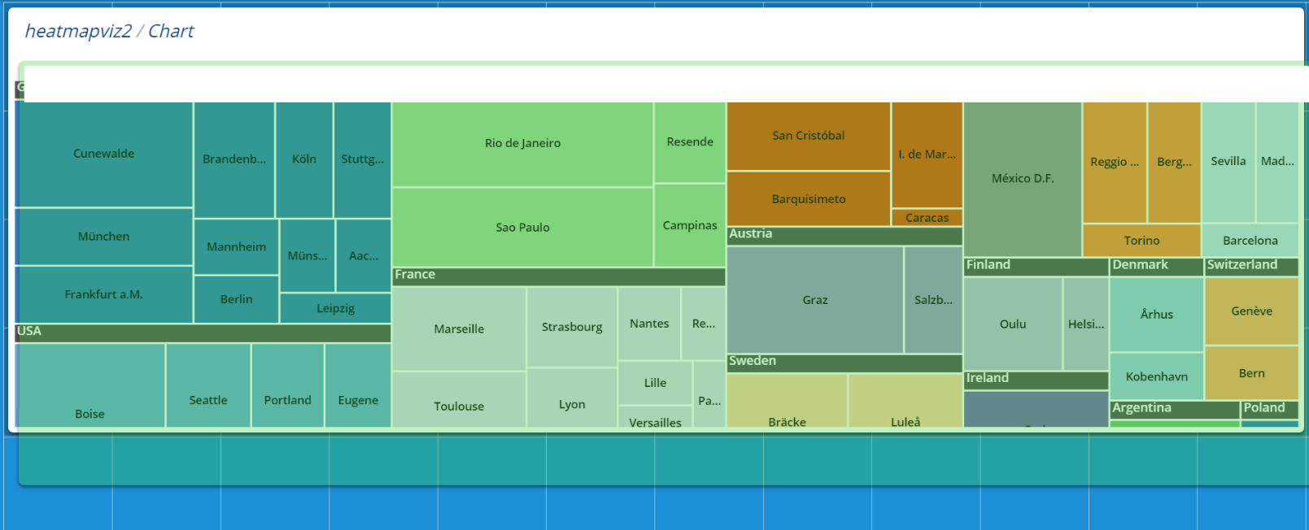

Improperly Placed Tile for move (red hue)

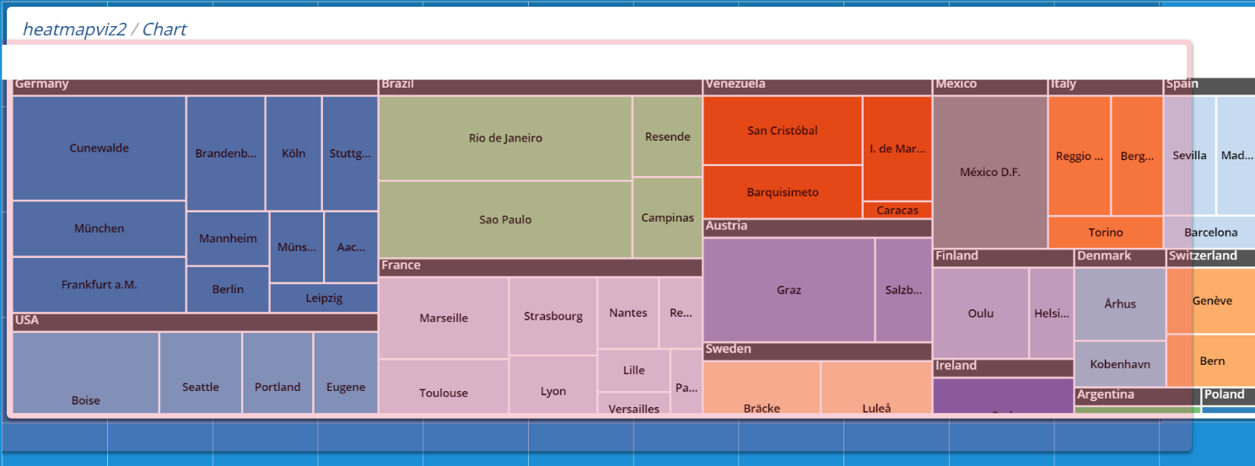

**Tile Customizations**

There are several options available for customizing a tile. These options can be found by clicking on the menu button in the top right corner of the specific tile. The tile will then spin to the reverse side, revealing the additional options.

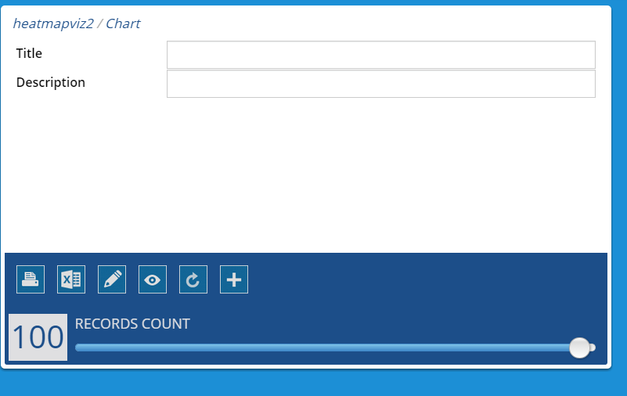

The user can now choose to add a Tile that is displayed on the front of the tile along with a Description that is also displayed on the tile

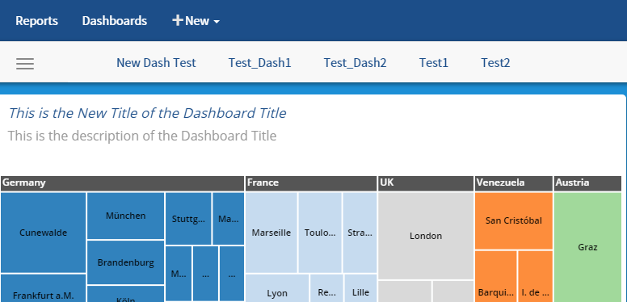

The additional following menu items are available for use on the back of each dashboard tile

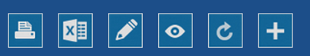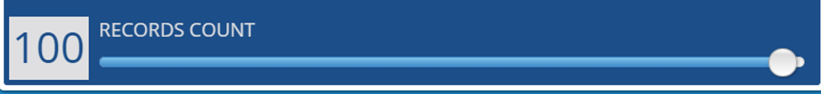

| **Appearance** | **Description** |
| --- | --- |
| http://wiki.izenda.us/Guides/Dashboards-v2/15.png | Print tile report – prints the tile from dashboard |
| http://wiki.izenda.us/Guides/Dashboards-v2/16.png | Export tile report to Excel |
| http://wiki.izenda.us/Guides/Dashboards-v2/17.png | Opens the Report the tile is created from in report editor |
| http://wiki.izenda.us/Guides/Dashboards-v2/18.png | Opens the Report the tile is created from in the report viewer |
| http://wiki.izenda.us/Guides/Dashboards-v2/19.png | Reloads the tile from report |
| http://wiki.izenda.us/Guides/Dashboards-v2/20.png | Add a new report part to tile (change report part selected from original report) |
| http://wiki.izenda.us/Guides/Dashboards-v2/21.png | Change the Number of Records to be displayed in the tile |

**Securing the Dashboard**

Now that you have created your dashboard you will want to secure it to insure that it is available to the appropriate audience with the appropriate rights. To secure the dashboard click the **Main menu** icon and select the **Share** icon.



You will be presented with a dialog window allowing you to set the following:

1. Group with which to share the dashboard.
2. Rights for that group.
3. Add additional groups and rights.

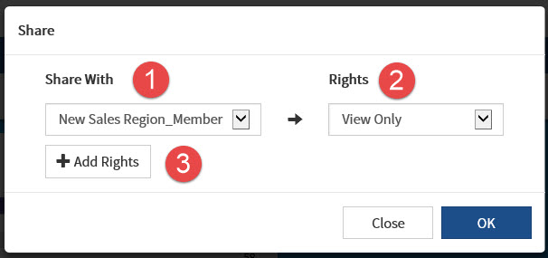

Make the appropriate security changes and then save the dashboard.

# For more information about configuring ClientSpace security for Business Intelligence read [Configuring Security In Ad-Hoc And Business Intelligence Reporting](https://clientspace.atlassian.net/wiki/x/SABhAg).

**Viewing an Existing Dashboard**

Click on Dashboard at the Top Navigation Bar

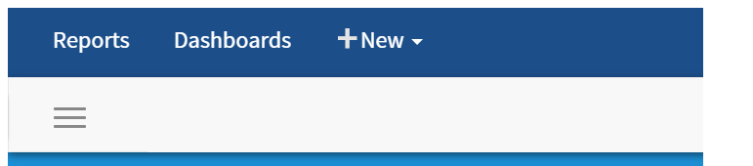

Dashboards will be displayed as tabs in the window with the active window highlighted from below:

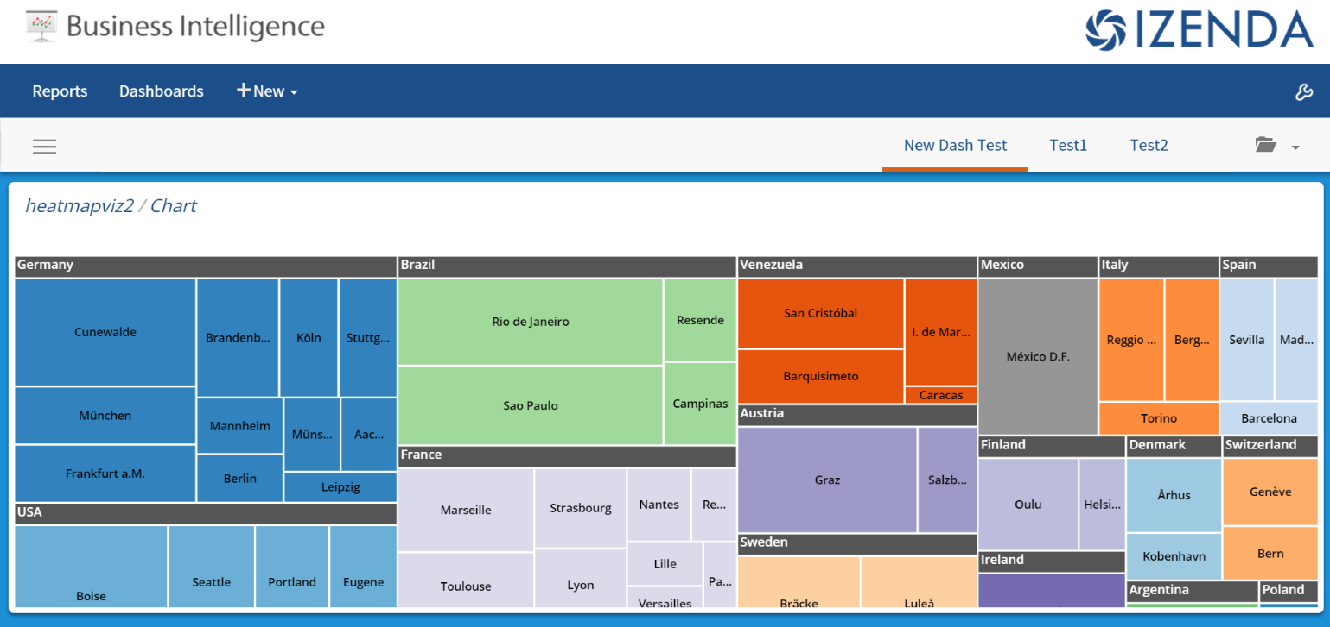

**Main Dashboard Menu**

This menu offers the following menu options are available from the menu button in the top left navigation bar when expanded



| **Appearance** | **Description** |
| --- | --- |
| http://wiki.izenda.us/Guides/Dashboards-v2/26.png | Collapse Menu |
|  | Presentation Mode – Allows the user to scroll through the Dashboard tiles in a carousel |
| http://wiki.izenda.us/Guides/Dashboards-v2/28.png | Create a New Dashboard |
| http://wiki.izenda.us/Guides/Dashboards-v2/29.png | Refresh Dashboard |
| http://wiki.izenda.us/Guides/Dashboards-v2/30.png | View Filters – Each report in the dashboard must share the same filter to be displayed |
| http://wiki.izenda.us/Guides/Dashboards-v2/31.png | Share Dashboard with other users |
| http://wiki.izenda.us/Guides/Dashboards-v2/32.png | Schedule Dashboard - Sends dashboard via email at a scheduled time  Requires you to save the schedule, then save the associated Dashboard |
| http://wiki.izenda.us/Guides/Dashboards-v2/33.png | Print Dashboard = Prints Dashboard HTML or Report PDF |
| http://wiki.izenda.us/Guides/Dashboards-v2/34.png | Save Dashboard - Saves dashboard as different name or pdf file |
|  | Send via Email – Send dashboard as a link or embedded pdf document |
| http://wiki.izenda.us/Guides/Dashboards-v2/35.png | Change Dashboard - Changes background image |